Operations Research Question Bank
Unit- V
1 Mark Questions
- Define a Network
- There are ………. Types of Network techniques
- Shortest path model can be classified in to ………. types
- Shortest path between only one pair of nodes can be determined using…………..method or……………….
- Shortest path between any pair of nodes can be determined using…………..method
- Minimum spanning tree problem can be solved using…………
- Define shortest path model
- In transport organizations, one of the objectives is……………….
10. Objective of Maximum flow problem is………..
11. What is minimum spanning problem?
12. Floyd’s algorithm is used to find shortest path and corresponding distance from …………… to …………….. Node in a given distance network.
13. Specify the first step in dijkstra’s algorithm
14. In Floyd’s Algorithm, diagonal values of the initial distance matrix are assumed as …………..
15. Floyd’s Algorithm takes…………….. And ……………… as input
2 mark Questions

- Expand MFP
- How many types of network techniques are there?
- Determination of shortest path using specialized procedures is known as ………………
- Each node in the network represents……………
- Each edge in the network represents……………
- Number on each edge in a network denotes………….
- How many methods are used to find shortest path in a distance network?
- In dijkstra’s algorithm, arcs in network may be ………….
- In dijkstra’s algorithm, if there is no direct arc from start node to another node, corresponding distance is assumed as …..
- Prim Algorithm is used to find solution for ………………
5 Mark Questions

- Describe Dijkstra’s Algorithm
- Explain Floyd’s Algorithm
- Explain Prims Algorithm
- Describe Kruskal’s Algorithm
- Write Maximal Flow problem Algorithm

10 Mark Questions

- Consider the following Road Network as shown below. Find the shortest path from city 1 to city 10 using systematic model Find

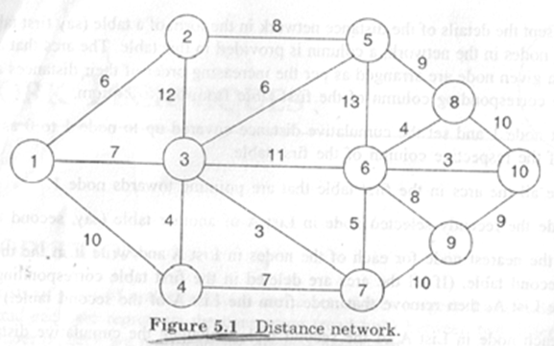

- Find the shortest path from node 1 to node 9 of the distance network shown below using Dijkstra’s Algorithm

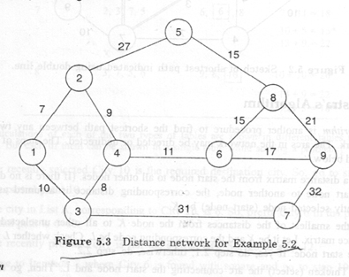

- Consider the following Network and apply Floyd’s Algorithm to it and generate final distance matrix and precedence matrix
- Explain about Prim’s and Kruskal’s Algorithms
- Describe about Dijkstra’s and Floyd’s Algorithms

